**They Cut The Power In Scam Centers, But Its Business As Usual**

Thailand cut electricity supplies on Wednesday to several areas in neighboring Myanmar that are home to sites at the center of a global, billion-dollar online scam industry.

In a recent report, Thailand’s Interior Minister Anutin Charnvirakul toured a control station at the national electricity grid as staff pulled the plug on supplies to five locations across the border, in an event broadcast live on television.

“The electricity supply is not being stopped because the companies violated the contract, but because the electricity is being misused for scams, drugs and call centers,” he said

But it is the power cut off working?

After the power was cut off, one scam operational center was still operating, calling into question how they managed to do so.

**Telegram Offers Clues – They Are Importing Power**

I browsed Telegram for answers and found evidence of what is happening. The scam centers are merely getting resourceful and finding different ways of getting power.

In one post, it appears that the area is importing power from Laos to keep the area plugged in.

After Thailand suspended power supply, Tachileik officials rapidly implemented a contingency plan to import electricity from Laos. The city's electricity management committee reports they began emergency operations at 9am when the Thai outage started. They expect to restore about 90% of the city's power by tonight through the Laos connection.

The technical implementation is happening in phases:

* Core city areas will see full power restoration (100%) between 4-5pm today
* The "Feeder-2" zone, which is farther from the Laos grid connection point, still requires about 25% more infrastructure work and could take an additional week

What makes this particularly interesting from an infrastructure resilience perspective is how quickly Tachileik was able to pivot to an alternative power source. The statement came from a senior official with the Tachileik City Electricity Supply Management Committee during a 1pm press briefing on February 5th.

**Smugglers Are Bringing Over Oil and Gas**

Other photos and post on Telegram show various smugglers bringing in oil and gas canisters in trucks to fuel generators to the region.

Here is a truck that is bringing over Gas Canisters.

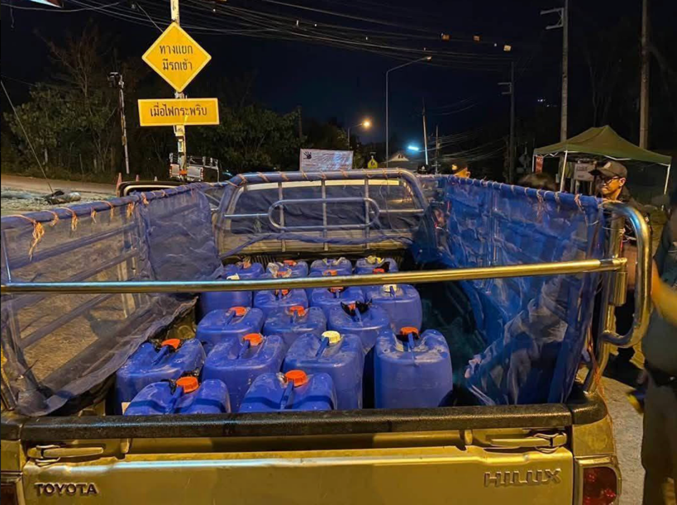

At the border fuel trucks are being held up.

**I Have 600,000 Fraudsters Under My Command**

In other post, ominous signs show that the scam centers could be lining up protest, In one particular post they say “I have 600,000 fraudsters under my command, The direction of my finger is the battlefield.

This is probably bragging but shows the scale of the scam operations centers in the area which have been allowed to grow to uncontrollable levels.

**The Thai Government Is Trying To Stop People From Smuggling**

The problem of smuggling has gotten so bad that the Thai government is urging people not to get caught up in smuggling.

Chiang Rai authorities on Saturday banned people from filling gas in fuel tanks and other kinds of containers in a bid to prevent call-centre scammers from accessing fuel to generate electricity.

The order has forced several Myanmar nationals to cross the Tachilek border to access fuel in Mae Sai district of Chiang Rai province, as some gas stations in Tachilek have limited gas refuelling to vehicles and banned them from using containers to fill gas.

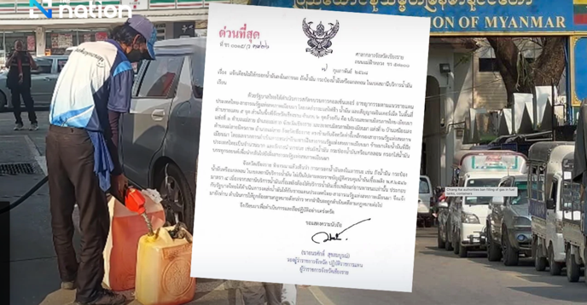

**Fraudsters Will Find A Way To Scam No Matter What You Do**

While Thailand has cut of power to the scam centers it’s obvious that scammers are finding ways to beat the system.

When the government shut off access to telecom and landlines, the scammers merely resorted to using Starlink and satellite telecommunications.

Where there is a will, there is a way.